CLR;
CSC:
JRE:
CIL:
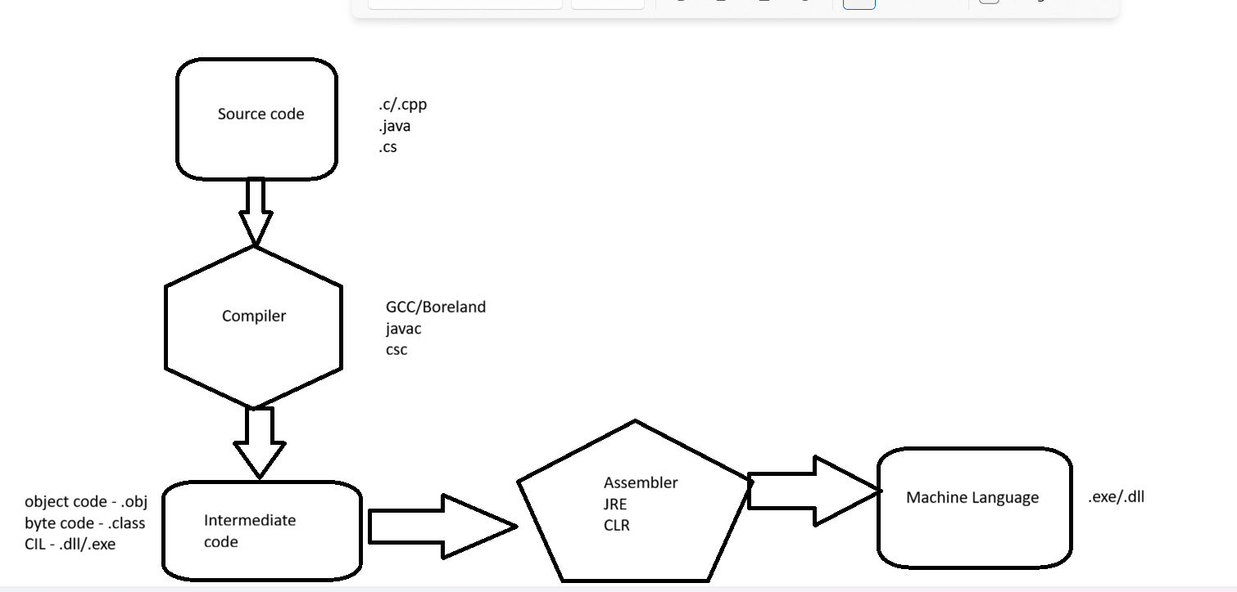

Interoperability:

Entity Framework Core:
ORM:
NuGet Packet Manager

